Journal-3

1. Create two files under "UNIX" directory name "BCA" and "BBA" withduplicate records( student id,name, city, Pincode, Sem, DOB).

Enter city "Bardoli" In more than 3 records.

Enter duplicate records also.

Date should be in dd/mm/yyyy format. Not Enter heading in file. See Below example.

Code:

Cat >BCA.txt

Cat >BBA.txt

Output:

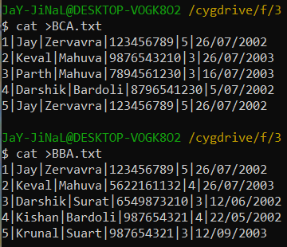

2. Write command to display first five lines from file "Intro" under "Web" Directory.

Code:

Head -5 Intro

Output:

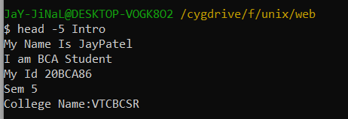

3. Display first 5 character of file "intro".

Code:

Head -c5 Intro

Output:

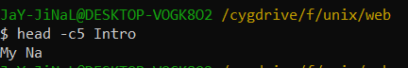

4. Count number of character from first five lines of file "Intro".

Code:

Head -n5 intro|wc -c

Output:

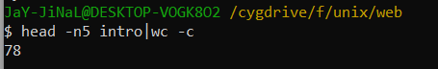

5. List 3 most recently used file in PWD.

Code:

Ls- lt

Output:

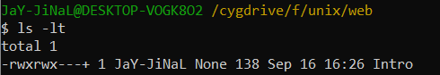

6. Display last five lines from file "Intro" under "Web" Directory.

Code:

Tail -n5 Intro

Output:

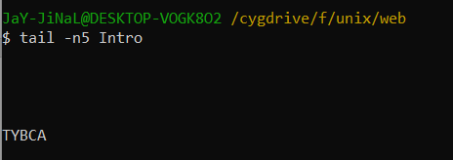

7. Count number of character in last line of "intro" file.

Code:

Tail Intro |wc -c

Output:

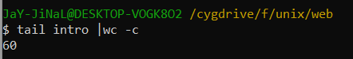

8. Display lines 4 to 9 from file "Intro".

Code:

Head -9 Intro|tail +4

Output:

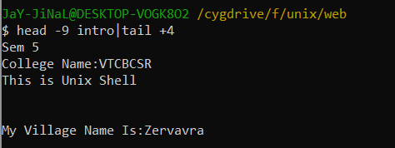

9. Display two lines starting from 7th line of file "intro".

Code:

Head -n8 intro | tail -2

Output:

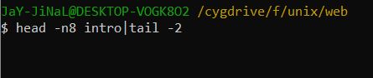

10. Count number of words in line 8 to 12 in file "intro".

Code:

Head -n12 intro | tail -5 |wc -c

Output:

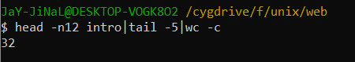

11. Display last five character of file "intro".

Code:

Tail -c5 intro

Output:

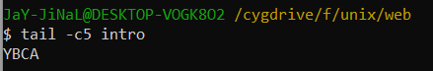

12. Display characters from 2oth byte of "Intro".

Code:

Tail -c+20 intro

Tail -c20 intro

Output:

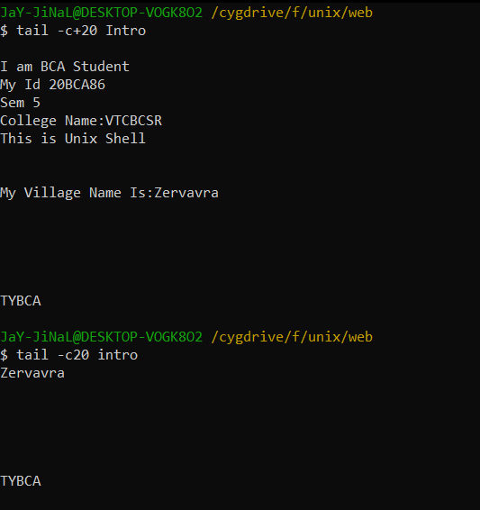

13. Display only 1st character of each lines.

Code:

Cut -c 1 Intro

Output:

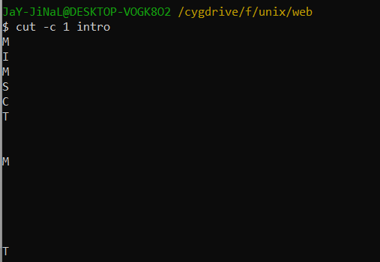

14. Display only 5 to 8 character of each lines.

Code:

Cut -c 5,6,7,8 Intro

Output:

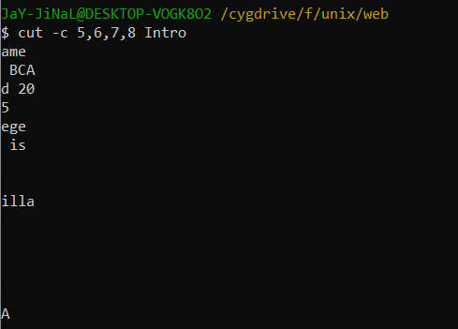

15. Display first 5 character of each lines.

Code:

Cut -c -5 Intro

Output:

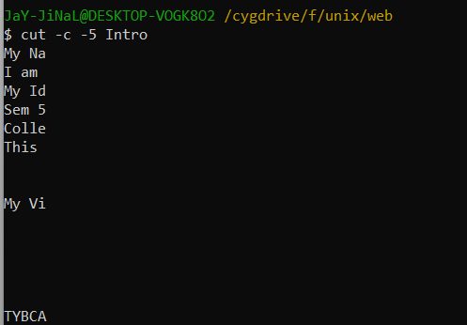

16. Display only 2nd field from "Stud" file of "Web".

Code:

Cut -d “,” -f2

Output:

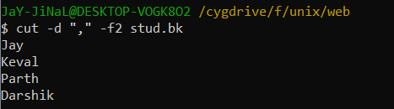

17. Display only 2nd to 3rd field from "Stud" file of "Web".

Code:

Cut -d “,” -f2,3 stud.bk

Output:

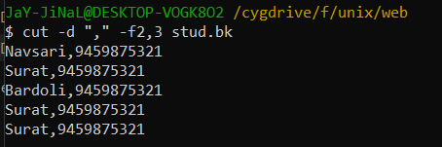

18. Display only 2,3, and 5 field form "Stud" file.

Code:

Cut -d “,” -f2,3,5 stud.bk

Output:

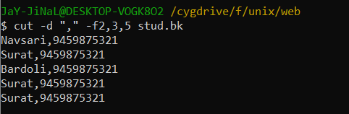

19. To Print field 2 to 5 from "stud" file.

Code:

Cut -d “,” -f2-5 stud.bk

Output:

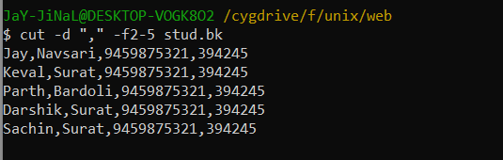

20. Merging two file "BCA" and "BBA" with delimiter ":".

Code:

Past -d ‘:’ BBA BCA

Output:

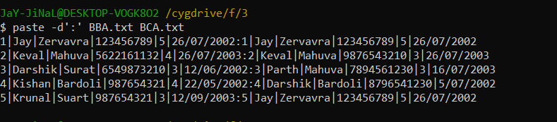

21. Sort File "BCA" .

Code:

Sort BCA

Output:

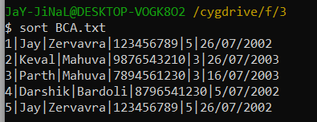

22. Sort File "BBA" and display only unique records. Use delimiter "|"

Code:

Sort BBA.txt|uniq

Output:

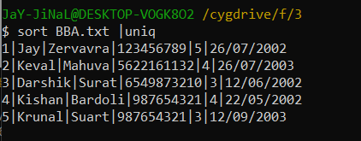

23. Sort File "BCA" on "ID" field.

Code:

Sort -k1,1 BCA

Output:

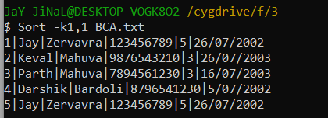

24. Sort file "BBA" on "Pincode" which is a numeric field in decending order.

Code:

Sort -r -k4n,4 BBA

Output:

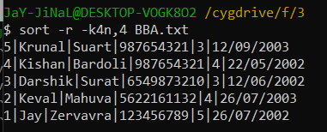

25. Sort file "BCA" on multiple field "ID" and "City" use delimiter ","

Code:

Sort -t ‘|’ -k1n,3 BCA

Output:

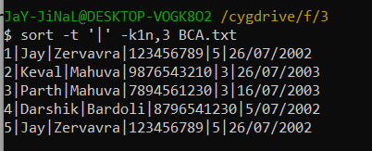

26. Sort file “BBA” on “Year Of Birth” in ascending order with delimiter “:”

Code:

sort -k 6.9,9.10 BBA.txt | tr '|' ':'

Output:

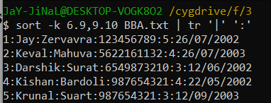

27. Sort file by last access time.

Code:

Ls -l | sort -k8 -k8.4,8.5n

Output:

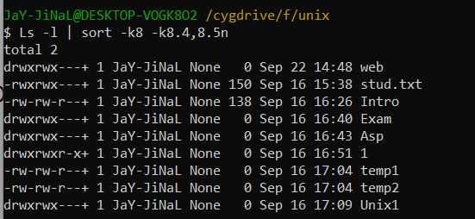

28. Display number of unique line in file "BCA".

Code:

$ uniq -c BCA.txt

Output:

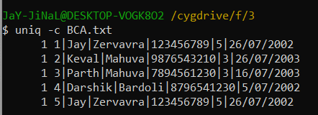

29. Display unique line from file "BCA".

Code:

uniq BCA.txt

Output:

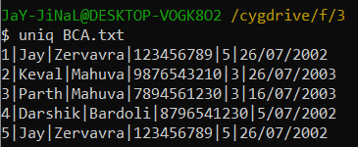

30. To remove duplicate line from a file “BBA”.

Code:

uniq -u BBA

Output:

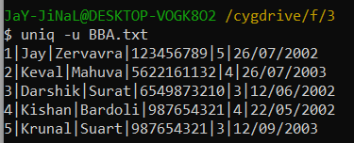

31. Display only duplicate line in file “BBA”.

Code:

uniq -d BBA.txt

Output:



32. Print frequency of each line from file “BCA”.

Code:

cat BCA.txt | tr -s ‘ ‘ ‘\n’ | sort | uniq -c | awk ‘{print$2,$1}’

Output:

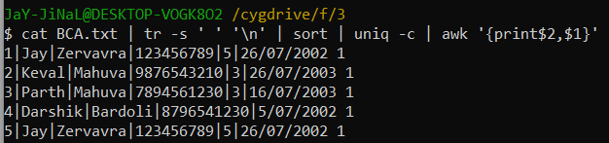

33. Move to "Web" Directory

Code:

Cd asp

Cd web

Output:

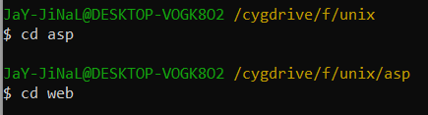

34. Translate "Intro" file into "Upper case".

Code:

Tr [a-z] [A-Z] < intro

Output:

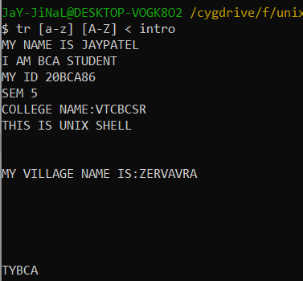

35. Translate "Stud" file with delimiter "-" and print only 3 records.

Code:

Cat stud.txt | tr ‘,-‘ ’-‘ | head -3

Output:

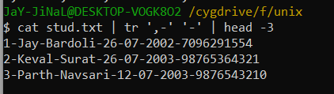

36. Delete vowel from "Intro" files.

Code:

tr -d [a,e,i,o,u] < intro

Output:

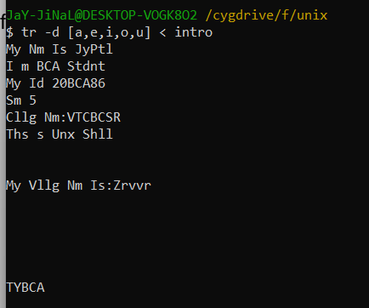

37. Remove all leading spaces from file "Into".

Code:

tr -s “ “ < intro

Output:

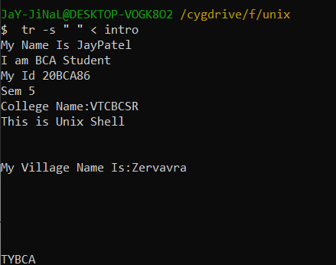

38. To delete all special character in "BCA" file.

Code:

Cat BCA.txt | tr -d ‘||’

Output:

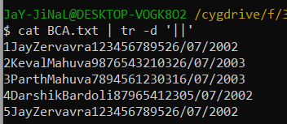

39. Replace multiple space between two words with single space.

Code:

Cat ibtro.txt | tr -s “ “

Output:

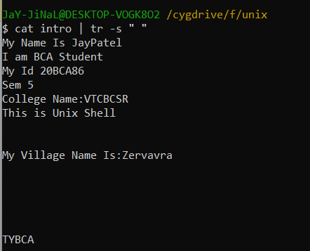

40. Write a command to sort a line of "BCA" file and remove repeated lines.

Code:

Cat BCA.txt | uniq

Output:

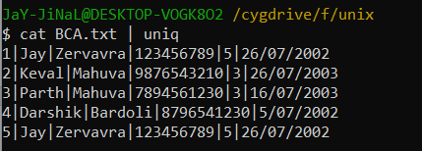

41. Replace all occurance of "Bardoli" with "Baroda" in"BBA".

Code:

Tr “Bardoli” “Baroda” < BBA.txt

Output:

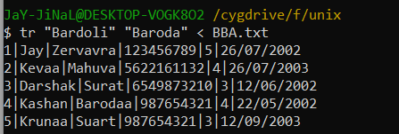

42. Replace all occurance of "Bardoli" with "Baroda" in 5th line of "BCA"

Code:

Head -5 BCA.txt tail +5 | tr “Bardoli” “Baroda”

Output:

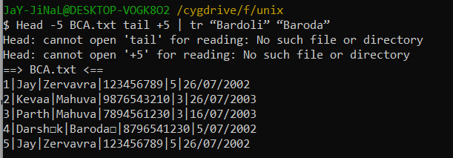

43. Count all occurance of "My" in "Intro" file

Code:

Cut -f 1 Intro | grep -I “My” | wc -l

Output:

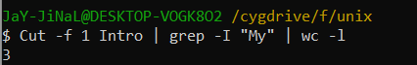

44. To Count the number of words in line 5 to line 10 of file "Intro".

Code:

Head -10 intro | tail +5 | wc -c

Output:

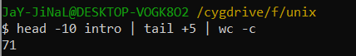

45. To move all files begin with digit from parent directory to the current directory.

Code:

find | grep "^[1-9]" | cd

Output:

